Dezhi, Fawwaz, Matthew, Tien

University Library System

ECS740P – Database Systems

Coursework 2

Group 27

Introduction

Relational Schema

Creating Tables

Views

Triggers

Data

Queries

Security Considerations

Introduction

This second report concerns the implementation of the conceptual database system outlined in our previous report. We will be using Oracle’s Live SQL environment to build and test all data. We will cover the creation of tables, views (virtual tables) and triggers, fill the system with test data and then run several queries to demonstrate possible use cases. Appropriate constraints will be implemented in our system in various ways to ensure data integrity, validity, and security. Our original conceptual schema is described below, primary keys are shown by underlined attributes and italicised attributes represent foreign keys.

**Subject** (Subject Code, Subject Title)

**Resource Details** (Catalogue Number, *Subject Code*, Maker, Publisher, Title, Publication Year, Format)

**Resource Location** (Location ID, Floor Number, Shelf Mark)

**Resource** (Resource ID, *Catalogue Number*, *Location ID*, Loan Period)

**Membership Constraints** (Member Class, Daily Fine Rate, Loan Limit)

**Member** (Library Card ID, *Member Class*, Full Name, Email, Status, Registration Date)

**Loan** (Loan ID, *Library Card ID*, *Resource ID*, Loan Start Date, Return Date)

**Fines Payment** (Payment ID, *Library Card ID*, Payment Date, Amount Paid)

Relational Schema

Upon reflection, we decided that our original schema needed to be amended slightly before proceeding with the implementation stage. Entities containing the word “Resource” have been changed to include the term “Item”, as “Resource” is a reserved keyword in Oracle. The only significant changes are to the Fines Payment table. The primary key has been changed to a composite key composed of 3 foreign keys, and “Amount Paid” was changed to “Total Paid”. The updated schema is reflected in the description below. This is the exact format that will be used to actually construct the system. Attributes that are both underlined and in italics are foreign primary keys.

**Subject** (Subject Code, Subject Title)

**Item Details** (Catalogue Number, *Subject Code*, Maker, Publisher, Title, Publication Year, Format)

**Item Location** (Location ID, Floor Number, Shelf Mark)

**Item** (*Item ID*, *Catalogue Number*, *Location ID*, Loan Period)

**Membership Constraints** (Member Class, Daily Fine Rate, Loan Limit)

**Member** (Library Card ID, *Member Class*, Full Name, Email, Status, Registration Date)

**Loan** (Loan ID, *Library Card ID*, *Item ID*, Loan Start Date, Return Date)

**Fines Payment** (*Loan ID*, *Library Card ID*, *Item ID*, Payment Date, Total Paid)

Creating Tables

We have 8 tables to create and they have to be structured and created in a specific sequence and this means they have to run in a specific order. This is because particular relations possess foreign keys and coding for a foreign key column before its table exists crashes the code, the solution was to create these tables beforehand.

The reason we used the VARCHAR2 datatype instead of VARCHAR is because although VARCHAR is defined in the ANSI standard, Oracle’s implementation of VARCHAR is actually not ANSI-compliant because it considers an empty string to be equivalent to NULL. Oracle may change this in the future thereby breaking legacy compatibility. However VARCHAR2 is functionally identical and will never be changed thus it is preferable to use it to ensure the functionality of the system does not change over time.

Subject Table

Within the subject table, subject_code is given the primary key constraint. Therefore, all values within this column are both unique and not null. The only other attribute that accompanies subject_code is subject_title. Subject_title is also constrained by being not null. It is paramount the information of subject_title corresponds to the correct subject code – this was achieved. The primary key subject_code would later be used a foreign key for another relation: item_details.

CREATE TABLE subject (

subject_code NUMBER(5) NOT NULL,

subject_title VARCHAR2(255) NOT NULL,

CONSTRAINT pk_subcode PRIMARY KEY (subject_code)

);

Item Location Table

Within the item_location table, location_id is given the primary key constraint. Therefore, all values within this column are both unique and not null. The other attributes that accompany location_id are floor_number and shelf_mark. Floor_number and shelf_mark are also constrained by being not null. In addition to this, floor_number is also constrained with a CHECK, this check is to ensure the number of integers are 1 digit long and only 1 digit long. This was fulfilled through the line of code: CONSTRAINT chk_floornum CHECK (LENGTH(floor_number) =1. The purpose of this table was to ultimately create a primary key, location_id, to become a foreign key for the item relation table.

CREATE TABLE item_location (

location_id NUMBER(10) NOT NULL,

floor_number NUMBER(1) NOT NULL,

shelf_mark NUMBER(10) NOT NULL,

CONSTRAINT pk_loc PRIMARY KEY (location_id),

CONSTRAINT chk_floornum CHECK (LENGTH(floor_number) = 1)

);

Item Details Table

Within the item_details table, the attribute catalogue_number is given the primary key constraint. Therefore, all values within this column are unique, not null and constrained to a mandatory 10 digit combination. The other attributes that accompany catalogue_number are: subject_code, maker, publisher, title, publication_year and format_type. As mentioned before subject_code is constrained as a foreign key in this table to reference the subject table and is constrained with not null. The practice of using subject_code as a foreign key successfully ties together a catalogue_number with the subject it regards. The other attributes are also constrained with not null and further constraints are given to format_type - an item in this relation can exist only as: ‘BOOK’, ‘CD’, ‘DVD’ or ‘VHS’. The final attribute with a constraint is publication_year with a mandatory length of 4 digits to detail the year of the publication for the item. Only one instance of a catalogue number is recorded within this table and it is not possible to track each copy of an item through this table on its own. The purpose is solely for information about the items held within the library.

CREATE TABLE item_details (

catalogue_number NUMBER(10) NOT NULL,

subject_code NUMBER(5) NOT NULL,

maker VARCHAR2(255) NOT NULL,

publisher VARCHAR2(255) NOT NULL,

title VARCHAR2(255) NOT NULL,

publication_year NUMBER(4) NOT NULL,

format_type VARCHAR2(255) NOT NULL,

CONSTRAINT pk_catnum PRIMARY KEY (catalogue_number),

CONSTRAINT fk_subcode FOREIGN KEY (subject_code)

REFERENCES subject (subject_code),

CONSTRAINT chk_catnum CHECK (LENGTH(catalogue_number) = 10),

CONSTRAINT chk_format_type CHECK (format_type IN ('BOOK', 'CD', 'DVD', 'VHS')),

CONSTRAINT chk_pubyear CHECK (LENGTH(publication_year) = 4)

);

Item Table

Within the item table, the attribute item_id is given the primary key constraint. Therefore, all values within this column are both unique and not null. Catalogue_number is a foreign key and references the item_details table. Location_id is also a foreign key and references the item_location table. Loan_period is also constrained with a check where number values within this column loan_period must be either 14, 2 or 0. All attributes in this table are constrained with not null.

CREATE TABLE item (

item_id NUMBER(10) NOT NULL,

catalogue_number NUMBER(10) NOT NULL,

location_id NUMBER(10) NOT NULL,

loan_period NUMBER(2) NOT NULL,

CONSTRAINT pk_itemid PRIMARY KEY (item_id),

CONSTRAINT fk_catnum FOREIGN KEY (catalogue_number)

REFERENCES item_details (catalogue_number),

CONSTRAINT fk_locid FOREIGN KEY (location_id)

REFERENCES item_location (location_id),

CONSTRAINT chk_loanperiod CHECK (loan_period IN (14, 2, 0))

);

Member Constraint Table

Within this table, member_class is given the primary key constraint. Therefore, all values within this column are both unique, not null and are constrained to have string values ‘STUDENT’ or ‘STAFF’. As member of the college library can only be a student or staff member. All the attributes within this table are constrained with not null. Loan_limit is further constrained with a CHECK, this check is to ensure that only digits 5 and 10 are within the loan_limit column. The purpose of member_class primary key is to become a foreign key for the members table. Daily_fine_rate details the fine rate owed to the library if a member has not returned an item by the due date.

CREATE TABLE member_constraints (

member_class VARCHAR2(255) NOT NULL,

daily_fine_rate NUMBER(2) NOT NULL,

loan_limit NUMBER(2) NOT NULL,

CONSTRAINT pk_memberclass PRIMARY KEY (member_class),

CONSTRAINT chk_memberclass CHECK (member_class IN ('STUDENT', 'STAFF')),

CONSTRAINT chk_loanlimit CHECK (loan_limit IN (5, 10))

);

Members Table

Within this table, library_card_id is given the primary key constraint. Therefore, all values within this column are both unique and not null. Member_class is a foreign key which references the table Member Constraints and is also not null. All other attributes within this table are constrained to being not null. Additional CHECK constraints are given to the attributes status and email. For status, the check ensures the string values are either ‘ACTIVE’ or ‘SUSPENDED’. For email the check ensures the email contains an @ and a full stop to ensure emails are entered correctly. Having said this, if a user presses a full stop before the @ there is no system to prevent this from being entered, perhaps more specificity is needed here.

CREATE TABLE members (

library_card_id NUMBER(10) NOT NULL,

member_class VARCHAR2(255) NOT NULL,

full_name VARCHAR2(255) NOT NULL,

email VARCHAR2(255) NOT NULL,

status VARCHAR2(255) NOT NULL,

registration_date DATE NOT NULL,

CONSTRAINT pk_libcardid PRIMARY KEY (library_card_id),

CONSTRAINT fk_memberclass FOREIGN KEY (member_class)

REFERENCES member_constraints (member_class),

CONSTRAINT chk_status CHECK (status IN ('ACTIVE', 'SUSPENDED')),

CONSTRAINT chk_email CHECK (email LIKE '%@%'),

CONSTRAINT chk_email2 CHECK (email LIKE '%.%')

);

Loan Table

Within this table, loan_id is given the primary key constraint. Therefore, all values within this column are both unique and not null. Library_card_id is a foreign key and references the members table. Item_id is also a foreign key and references the item table. All attributes within this table are constrained to being not null. An additional CHECK constraint is added between loan_start_date and return_date attributes to prevent an impossibility that a loan can have a later date than the return date. This was achieved through this line of code: CONSTRAINT chk_loandate_returndate CHECK (loan_start_date < return_date).

CREATE TABLE loan (

loan_id NUMBER(10) NOT NULL,

library_card_id NUMBER(10) NOT NULL,

item_id NUMBER(10) NOT NULL,

loan_start_date DATE NOT NULL,

return_date DATE,

CONSTRAINT pk_loanid PRIMARY KEY (loan_id),

CONSTRAINT fk_libcardid FOREIGN KEY (library_card_id)

REFERENCES members (library_card_id),

CONSTRAINT fk_itemid FOREIGN KEY (item_id)

REFERENCES item (item_id),

CONSTRAINT chk_loandate_returndate CHECK (loan_start_date < return_date)

);

Fines Payment Table

Within this table, loan_id, library_card_id and item_id are given the primary key constraint. It was decided to use a composite primary key for this table to provide specific detail of members of the college library who have paid fines and to identify them. The other attributes payment_date and total_paid are constrained as not null.

CREATE TABLE fines_payment (

loan_id NUMBER(10) REFERENCES loan (loan_id) NOT NULL,

library_card_id NUMBER(10) REFERENCES members (library_card_id) NOT NULL,

item_id NUMBER(10) REFERENCES item (item_id),

payment_date DATE NOT NULL,

total_paid NUMBER(10) NOT NULL,

PRIMARY KEY (loan_id, library_card_id, item_id)

);

Views

One way of improving the functionality of our system is through the implementation of views (virtual tables). Views allow us to represent complex queries to the user in a more coherent manner that abstracts away the complexity of the database design. This section outlines 4 views which we implemented.

**Popular Items**

Now to create this view to discover popular loans required two JOINS. The initial INNER JOIN was between tables loan and item on matching values in attributes for item_id. The second INNER JOIN was between item_details and item to match values in attributes for catalogue_number. The WHERE clause is used to specify loans that have been returned and then columns are grouped by item_details.catalogue_number and item_details.title, then ordered from highest to lowest frequency to clearly identify the most popular title that has been on loan and returned. This view would be useful for the library admins to identify popular titles, and through using this VIEW in SQL Queries they could identify the most popular subjects and format types too. However, in this case the title of the items also details the format type and subject and so it is possible to identify the most popular format types and subject from this VIEW alone as the screenshots indicate.

CREATE VIEW popular_item AS

SELECT COUNT(item_details.catalogue_number) AS highest_frequency, item_details.catalogue_number, item_details.title

FROM loan

INNER JOIN item ON item.item_id = loan.item_id

INNER JOIN item_details ON item_details.catalogue_number = item.catalogue_number

WHERE return_date IS NOT NULL

GROUP BY item_details.catalogue_number, item_details.title

ORDER BY highest_frequency DESC;

SELECT * FROM popular_item;

**Current Loans**

This VIEW is similar to the one above. This VIEW was created through an INNER JOIN on matching attributes item_id from tables loan and item. Choice of the set of attributes was pivotal to make this VIEW informative to admins of the library by showing what specific catalogue_numbers are on loan and who has that item on loan. Through an INNER JOIN on item_id from both loan and item tables it was possible to match which items are on loan. Additionally, a WHERE clause was added to exclude items that have been returned to the library and so only data of items still on-loan were extracted through the script line: WHERE loan.return_date IS NULL; Users will be able to identify which catalogue numbers are still on loan and when to expect their return through adding loan_period to the loan_start_date.

CREATE VIEW current_loans AS

SELECT loan.loan_id, item.catalogue_number, loan.loan_start_date, item.loan_period, loan.library_card_id

FROM loan

INNER JOIN item ON loan.item_id = item.item_id

WHERE loan.return_date IS NULL;

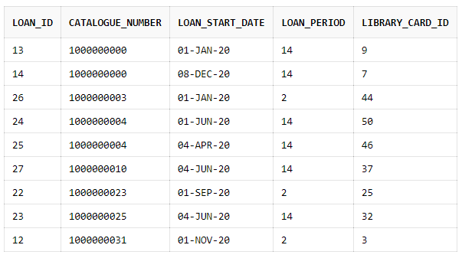**Current Suspensions**

This VIEW was created with the joining of three tables: loan, item and members. The purpose of this view is to automate data from three tables. Members of the library are suspended due to withholding a loan past its loan period and accruing overdue fines totalling a number greater than 10, then they are found in this table. This is achieved by initially matching item_id values between the item and loan tables through an INNER JOIN. With the results, a LEFT JOIN is used with the members table on matching library_card_id attributes between members and loan table. A WHERE clause is then used on attributes return_date (which is set equal to: IS NULL) and members.status (equated to: ‘SUSPENDED’) and (ROUND(SYSDATE - (item.loan_period + loan.loan_start_date), 2)) > 10 detailing overdue loans and fines exceeding the £10. This VIEW is useful for admins of the library to identify members who are still due to pay their fines and return loans they have.

CREATE VIEW current_suspensions AS

SELECT loan.loan_id, loan.item_id, loan.library_card_id, loan.loan_start_date, members.member_class, members.full_name, members.email,

members.registration_date

FROM loan

INNER JOIN item

ON item.item_id = loan.item_id

LEFT JOIN members ON members.library_card_id = loan.library_card_id

WHERE return_date IS NULL AND members.status = 'SUSPENDED' AND (ROUND(SYSDATE - (item.loan_period + loan.loan_start_date), 2)) > 10

ORDER BY loan_id ASC;

SELECT * FROM current_suspensions;

**Fines Due**

For this VIEW, tables loan and item were joined with a select few attributes chosen from them. The aim of this view is to correctly calculate the fine amount due from members who have withheld items and incurred a fine. This includes members who are either suspended or just owe a fine on its own. This VIEW will be useful for library admins to see how much is owed to the library and members to see how much they owe to the library. Additionally, the code uses a ROUND function to 2 decimal places and SYSDATE which has a metric that goes right to the second, as a result, amount due increases as time progresses. Each day results in a £1 increase. This is seen as a huge success of the code and reaches the specification expectation. (Amount_Due values will be different as time has progressed)

CREATE VIEW fines_due AS

SELECT loan_id, loan.library_card_id, loan.item_id, (item.loan_period + loan.loan_start_date) AS return_deadline,

(ROUND(SYSDATE - (item.loan_period + loan.loan_start_date), 2)) AS amount_due

FROM loan

INNER JOIN item

ON item.item_id = loan.loan_id

WHERE return_date IS NULL;

SELECT * FROM fines_due;

(This line of code was included to show there’s no mistake in our understanding that ORACLE will not display the table without the script line: SELECT * FROM fines_due;)

Triggers

With regards to trigger implementation, BEFORE row triggers are more computationally efficient than AFTER row triggers because “with AFTER row triggers, affected data blocks must be read (logical read, not physical read) once for the trigger and then again for the triggering statement. Alternatively, with BEFORE row triggers, the data blocks must be read only once for both the triggering statement and the trigger.” (Oracle documentation).

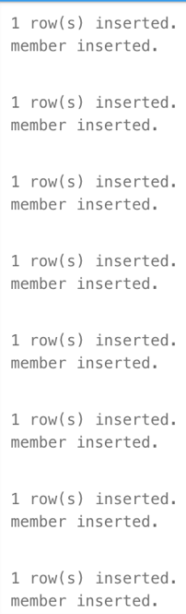**Member Entry**

CREATE OR REPLACE TRIGGER member_entry

BEFORE INSERT ON members

BEGIN

DBMS_OUTPUT.PUT_LINE('member inserted.');

END;

/

This trigger is to indicate upon inserting data into the members table a system response of “member inserted” per insertion. A simple trigger that is to inform users that they have successfully inserted a new piece of data for the table member. To view the results as seen on the screenshot insert data into the member table – we have provided the data for this below, simply copy and paste the script and the results will be seen as the screenshot shows.

**Loan Entry**

CREATE OR REPLACE TRIGGER loan_insert

BEFORE INSERT ON loan

BEGIN

DBMS_OUTPUT.PUT_LINE('loan inserted.');

END;

/

This trigger is to indicate upon inserting data into the loan table a system response of “loan inserted” per insertion. A simple trigger that is to inform users that they have successfully inserted a new piece of data for the table loan. To view the results as seen on the screenshot insert data into the loan table – we have provided the data for this below, simply copy and paste the script and the results will be seen as the screenshot shows.

**Item Entry**

CREATE OR REPLACE TRIGGER item_insert

BEFORE INSERT ON item

BEGIN

DBMS_OUTPUT.PUT_LINE('item inserted.');

END;

/

This trigger is to indicate upon inserting data into the item table a System response of “item inserted” per insertion. A simple trigger that is to inform users that they have successfully inserted a new piece of data for the table item. To view the results as seen on the screenshot insert data into the item table – we have provided the data for this below, simply copy and paste the script and the results will be seen as the screenshot shows.

**Item Details Entry**

CREATE OR REPLACE TRIGGER item_details_insert

BEFORE INSERT ON item_details

BEGIN

DBMS_OUTPUT.PUT_LINE('item details inserted.');

END;

/

This trigger is to indicate upon inserting data into item_details table a System response of “item details inserted” per insertion. A simple trigger that is to inform users that they have successfully inserted a new piece of data for the table item_details. To view the results as seen on the screenshot insert data into the item_details table – we have provided the data for this below, simply copy and paste the script and the results will be seen as the screenshot shows.

Data

This section serves as a reference for all of the test data we entered into the system.

**Subject**

INSERT INTO subject (subject_code, subject_title) VALUES ('000', 'Computer Science, information and general works');

INSERT INTO subject (subject_code, subject_title) VALUES ('100', 'Philosophy and Psychology');

INSERT INTO subject (subject_code, subject_title) VALUES ('200', 'Religion');

INSERT INTO subject (subject_code, subject_title) VALUES ('300', 'Social Sciences');

INSERT INTO subject (subject_code, subject_title) VALUES ('400', 'Language');

INSERT INTO subject (subject_code, subject_title) VALUES ('500', 'Pure Science');

INSERT INTO subject (subject_code, subject_title) VALUES ('600', 'Technology');

INSERT INTO subject (subject_code, subject_title) VALUES ('700', 'Arts & Recreation');

INSERT INTO subject (subject_code, subject_title) VALUES ('800', 'Literature');

INSERT INTO subject (subject_code, subject_title) VALUES ('900', 'History & Geography');

**Item Location**

INSERT INTO item_location (location_id, floor_number, shelf_mark) VALUES (001, 1, 0001);

INSERT INTO item_location (location_id, floor_number, shelf_mark) VALUES (002, 1, 0002);

INSERT INTO item_location (location_id, floor_number, shelf_mark) VALUES (003, 1, 0003);

INSERT INTO item_location (location_id, floor_number, shelf_mark) VALUES (004, 1, 0004);

INSERT INTO item_location (location_id, floor_number, shelf_mark) VALUES (005, 2, 0005);

INSERT INTO item_location (location_id, floor_number, shelf_mark) VALUES (006, 2, 0006);

INSERT INTO item_location (location_id, floor_number, shelf_mark) VALUES (007, 2, 0007);

INSERT INTO item_location (location_id, floor_number, shelf_mark) VALUES (008, 3, 0008);

INSERT INTO item_location (location_id, floor_number, shelf_mark) VALUES (009, 3, 0009);

INSERT INTO item_location (location_id, floor_number, shelf_mark) VALUES (010, 3, 0010);

**Item Details**

INSERT INTO item_details (catalogue_number, subject_code, maker, publisher, title, publication_year, format_type) VALUES (1000000000, 000, 'ClARK KENT', 'J.WILEY & SONS', 'THE BOOK OF COMPUTER SCIENCE, INFORMATION AND GENERAL WORKS', 1923, 'BOOK');

INSERT INTO item_details (catalogue_number, subject_code, maker, publisher, title, publication_year, format_type) VALUES (1000000001, 100, 'BRUCE WAYNE', 'PEARSON', 'THE BOOK OF PHILOSOPHY AND PSYCHOLOGY', 1919, 'BOOK');

INSERT INTO item_details (catalogue_number, subject_code, maker, publisher, title, publication_year, format_type) VALUES (1000000002, 200, 'HAL JORDAN', 'CAMBRIDGE', 'THE BOOK OF RELIGION', 2020, 'BOOK');

INSERT INTO item_details (catalogue_number, subject_code, maker, publisher, title, publication_year, format_type) VALUES (1000000003, 300, 'FRANKLIN RICHARDS', 'OXFORD', 'THE BOOK OF SOCIAL SCIENCES', 2018, 'BOOK');

INSERT INTO item_details (catalogue_number, subject_code, maker, publisher, title, publication_year, format_type) VALUES (1000000004, 400, 'ROBERTO MANCINI', 'MACMILLAN', 'THE BOOK OF LANGUAGE', 2016, 'BOOK');

INSERT INTO item_details (catalogue_number, subject_code, maker, publisher, title, publication_year, format_type) VALUES (1000000005, 500, 'ALBERT EINSTEIN', 'CENGAGE', 'THE BOOK OF PURE SCIENCE', 1924, 'BOOK');

INSERT INTO item_details (catalogue_number, subject_code, maker, publisher, title, publication_year, format_type) VALUES (1000000006, 600, 'ELON MUSK', 'CAMBRIDGE', 'THE BOOK OF TECHNOLOGY', 2003, 'BOOK');

INSERT INTO item_details (catalogue_number, subject_code, maker, publisher, title, publication_year, format_type) VALUES (1000000007, 700, 'JRR TOLKIEN', 'ALLEN & UNWIN', 'THE BOOK OF ARTS & RECREATION', 1955, 'BOOK');

INSERT INTO item_details (catalogue_number, subject_code, maker, publisher, title, publication_year, format_type) VALUES (1000000008, 800, 'WILLIAM SHAKESPEARE', 'J.WILEY & SONS', 'THE BOOK OF LITERATURE', 1576, 'BOOK');

INSERT INTO item_details (catalogue_number, subject_code, maker, publisher, title, publication_year, format_type) VALUES (1000000009, 900, 'MATTHEW MALLOY', 'MARVEL', 'THE BOOK OF HISTORY AND GEOGRAPHY', 2020, 'BOOK');

INSERT INTO item_details (catalogue_number, subject_code, maker, publisher, title, publication_year, format_type) VALUES (1000000010, 000, 'ClARK KENT', 'J.WILEY & SONS', 'THE CD OF COMPUTER SCIENCE, INFORMATION AND GENERAL WORKS', 2000, 'CD');

INSERT INTO item_details (catalogue_number, subject_code, maker, publisher, title, publication_year, format_type) VALUES (1000000011, 100, 'BRUCE WAYNE', 'PEARSON', 'THE CD OF PHILOSOPHY AND PSYCHOLOGY', 1999, 'CD');

INSERT INTO item_details (catalogue_number, subject_code, maker, publisher, title, publication_year, format_type) VALUES (1000000012, 200, 'HAL JORDAN', 'CAMBRIDGE', 'THE CD OF RELIGION', 2020, 'CD');

INSERT INTO item_details (catalogue_number, subject_code, maker, publisher, title, publication_year, format_type) VALUES (1000000013, 300, 'FRANKLIN RICHARDS', 'OXFORD', 'THE CD OF SOCIAL SCIENCES', 2020, 'CD');

INSERT INTO item_details (catalogue_number, subject_code, maker, publisher, title, publication_year, format_type) VALUES (1000000014, 400, 'ROBERTO MANCINI', 'MACMILLAN', 'THE CD OF LANGUAGE', 2018, 'CD');

INSERT INTO item_details (catalogue_number, subject_code, maker, publisher, title, publication_year, format_type) VALUES (1000000015, 500, 'BILL NYE', 'CENGAGE', 'THE CD OF PURE SCIENCE', 1999, 'CD');

INSERT INTO item_details (catalogue_number, subject_code, maker, publisher, title, publication_year, format_type) VALUES (1000000016, 600, 'ELON MUSK', 'CAMBRIDGE', 'THE CD OF TECHNOLOGY', 2010, 'CD');

INSERT INTO item_details (catalogue_number, subject_code, maker, publisher, title, publication_year, format_type) VALUES (1000000017, 700, 'VIGGO MORTENSEN', 'ALLEN & UNWIN', 'THE CD OF ARTS & RECREATION', 2001, 'CD');

INSERT INTO item_details (catalogue_number, subject_code, maker, publisher, title, publication_year, format_type) VALUES (1000000018, 800, 'BENJAMIN ZEPHANIAH', 'J.WILEY & SONS', 'THE CD OF LITERATURE', 2002, 'CD');

INSERT INTO item_details (catalogue_number, subject_code, maker, publisher, title, publication_year, format_type) VALUES (1000000019, 900, 'MATTHEW MALLOY', 'MARVEL STUDIOS', 'THE CD OF HISTORY AND GEOGRAPHY', 2020, 'CD');

INSERT INTO item_details (catalogue_number, subject_code, maker, publisher, title, publication_year, format_type) VALUES (1000000020, 000, 'MARK ZUCKERBERG', 'FACEBOOK', 'THE DVD OF COMPUTER SCIENCE, INFORMATION AND GENERAL WORKS', 2005, 'DVD');

INSERT INTO item_details (catalogue_number, subject_code, maker, publisher, title, publication_year, format_type) VALUES (1000000021, 100, 'DESCARTES', 'PEARSON', 'THE DVD OF PHILOSOPHY AND PSYCHOLOGY', 2005, 'DVD');

INSERT INTO item_details (catalogue_number, subject_code, maker, publisher, title, publication_year, format_type) VALUES (1000000022, 200, 'TOMMY THOMSON', 'CAMBRIDGE', 'THE DVD OF RELIGION', 2020, 'DVD');

INSERT INTO item_details (catalogue_number, subject_code, maker, publisher, title, publication_year, format_type) VALUES (1000000023, 300, 'JIM JASPERS', 'OXFORD', 'THE DVD OF SOCIAL SCIENCES', 2020, 'DVD');

INSERT INTO item_details (catalogue_number, subject_code, maker, publisher, title, publication_year, format_type) VALUES (1000000024, 400, 'CHRISTOPH WALTZ', 'MACMILLAN', 'THE DVD OF LANGUAGE', 2018, 'DVD');

INSERT INTO item_details (catalogue_number, subject_code, maker, publisher, title, publication_year, format_type) VALUES (1000000025, 500, 'BILL NYE', 'CENGAGE', 'THE DVD OF PURE SCIENCE', 2001, 'DVD');

INSERT INTO item_details (catalogue_number, subject_code, maker, publisher, title, publication_year, format_type) VALUES (1000000026, 600, 'KEANU REEVES', 'CAMBRIDGE', 'THE DVD OF TECHNOLOGY', 2010, 'DVD');

INSERT INTO item_details (catalogue_number, subject_code, maker, publisher, title, publication_year, format_type) VALUES (1000000027, 700, 'VIGGO MORTENSEN', 'ALLEN & UNWIN', 'THE DVD OF ARTS & RECREATION', 2001, 'DVD');

INSERT INTO item_details (catalogue_number, subject_code, maker, publisher, title, publication_year, format_type) VALUES (1000000028, 800, 'BENJAMIN ZEPHANIAH', 'J.WILEY & SONS', 'THE DVD OF LITERATURE', 2002, 'DVD');

INSERT INTO item_details (catalogue_number, subject_code, maker, publisher, title, publication_year, format_type) VALUES (1000000029, 900, 'MATTHEW MALLOY', 'MARVEL STUDIOS', 'THE DVD OF HISTORY AND GEOGRAPHY', 2020, 'DVD');

INSERT INTO item_details (catalogue_number, subject_code, maker, publisher, title, publication_year, format_type) VALUES (1000000030, 000, 'JIM CARREY', 'PEARSON', 'THE VHS OF COMPUTER SCIENCE, INFORMATION AND GENERAL WORKS', 1995, 'VHS');

INSERT INTO item_details (catalogue_number, subject_code, maker, publisher, title, publication_year, format_type) VALUES (1000000031, 100, 'DESCARTES', 'PEARSON', 'THE VHS OF PHILOSOPHY AND PSYCHOLOGY', 1998, 'VHS');

INSERT INTO item_details (catalogue_number, subject_code, maker, publisher, title, publication_year, format_type) VALUES (1000000032, 200, 'TOMMY THOMSON', 'CAMBRIDGE', 'THE VHS OF RELIGION', 1980, 'VHS');

INSERT INTO item_details (catalogue_number, subject_code, maker, publisher, title, publication_year, format_type) VALUES (1000000033, 300, 'JIM JASPERS', 'OXFORD', 'THE VHS OF SOCIAL SCIENCES', 1990, 'VHS');

INSERT INTO item_details (catalogue_number, subject_code, maker, publisher, title, publication_year, format_type) VALUES (1000000034, 400, 'CHRISTOPH WALTZ', 'MACMILLAN', 'THE VHS OF LANGUAGE', 1999, 'VHS');

INSERT INTO item_details (catalogue_number, subject_code, maker, publisher, title, publication_year, format_type) VALUES (1000000035, 500, 'BILL NYE', 'CENGAGE', 'THE VHS OF PURE SCIENCE', 2001, 'VHS');

INSERT INTO item_details (catalogue_number, subject_code, maker, publisher, title, publication_year, format_type) VALUES (1000000036, 600, 'KEANU REEVES', 'CAMBRIDGE', 'THE VHS OF TECHNOLOGY', 1999, 'VHS');

INSERT INTO item_details (catalogue_number, subject_code, maker, publisher, title, publication_year, format_type) VALUES (1000000037, 700, 'VIGGO MORTENSEN', 'ALLEN & UNWIN', 'THE VHS OF ARTS & RECREATION', 2001, 'VHS');

INSERT INTO item_details (catalogue_number, subject_code, maker, publisher, title, publication_year, format_type) VALUES (1000000038, 800, 'BENJAMIN ZEPHANIAH', 'J.WILEY & SONS', 'THE VHS OF LITERATURE', 2002, 'VHS');

INSERT INTO item_details (catalogue_number, subject_code, maker, publisher, title, publication_year, format_type) VALUES (1000000039, 900, 'MATTHEW MALLOY', 'MARVEL STUDIOS', 'THE VHS OF HISTORY AND GEOGRAPHY', 2002, 'VHS');

**Item**

INSERT INTO item (item_id, catalogue_number, location_id, loan_period) VALUES

(1, 1000000000, 1, 14);

INSERT INTO item (item_id, catalogue_number, location_id, loan_period) VALUES

(2, 1000000000, 1, 14);

INSERT INTO item (item_id, catalogue_number, location_id, loan_period) VALUES

(3, 1000000000, 1, 14);

INSERT INTO item (item_id, catalogue_number, location_id, loan_period) VALUES

(4, 1000000000, 1, 14);

INSERT INTO item (item_id, catalogue_number, location_id, loan_period) VALUES

(5, 1000000000, 1, 14);

INSERT INTO item (item_id, catalogue_number, location_id, loan_period) VALUES

(6, 1000000001, 2, 2);

INSERT INTO item (item_id, catalogue_number, location_id, loan_period) VALUES

(7, 1000000001, 2, 2);

INSERT INTO item (item_id, catalogue_number, location_id, loan_period) VALUES

(8, 1000000001, 2, 2);

INSERT INTO item (item_id, catalogue_number, location_id, loan_period) VALUES

(9, 1000000001, 2, 2);

INSERT INTO item (item_id, catalogue_number, location_id, loan_period) VALUES

(10, 1000000001, 2, 2);

INSERT INTO item (item_id, catalogue_number, location_id, loan_period) VALUES

(11, 1000000002, 3, 0);

INSERT INTO item (item_id, catalogue_number, location_id, loan_period) VALUES

(12, 1000000002, 3, 0);

INSERT INTO item (item_id, catalogue_number, location_id, loan_period) VALUES

(13, 1000000002, 3, 0);

INSERT INTO item (item_id, catalogue_number, location_id, loan_period) VALUES

(14, 1000000002, 3, 0);

INSERT INTO item (item_id, catalogue_number, location_id, loan_period) VALUES

(15, 1000000002, 3, 0);

INSERT INTO item (item_id, catalogue_number, location_id, loan_period) VALUES

(16, 1000000003, 4, 2);

INSERT INTO item (item_id, catalogue_number, location_id, loan_period) VALUES

(17, 1000000003, 4, 2);

INSERT INTO item (item_id, catalogue_number, location_id, loan_period) VALUES

(18, 1000000003, 4, 2);

INSERT INTO item (item_id, catalogue_number, location_id, loan_period) VALUES

(19, 1000000003, 4, 2);

INSERT INTO item (item_id, catalogue_number, location_id, loan_period) VALUES

(20, 1000000003, 4, 2);

INSERT INTO item (item_id, catalogue_number, location_id, loan_period) VALUES

(21, 1000000004, 5, 14);

INSERT INTO item (item_id, catalogue_number, location_id, loan_period) VALUES

(22, 1000000004, 5, 14);

INSERT INTO item (item_id, catalogue_number, location_id, loan_period) VALUES

(23, 1000000004, 5, 14);

INSERT INTO item (item_id, catalogue_number, location_id, loan_period) VALUES

(24, 1000000004, 5, 14);

INSERT INTO item (item_id, catalogue_number, location_id, loan_period) VALUES

(25, 1000000004, 5, 14);

INSERT INTO item (item_id, catalogue_number, location_id, loan_period) VALUES

(26, 1000000005, 6, 14);

INSERT INTO item (item_id, catalogue_number, location_id, loan_period) VALUES

(27, 1000000005, 6, 14);

INSERT INTO item (item_id, catalogue_number, location_id, loan_period) VALUES

(28, 1000000005, 6, 14);

INSERT INTO item (item_id, catalogue_number, location_id, loan_period) VALUES

(29, 1000000005, 6, 14);

INSERT INTO item (item_id, catalogue_number, location_id, loan_period) VALUES

(30, 1000000005, 6, 14);

INSERT INTO item (item_id, catalogue_number, location_id, loan_period) VALUES

(31, 1000000006, 7, 2);

INSERT INTO item (item_id, catalogue_number, location_id, loan_period) VALUES

(32, 1000000006, 7, 2);

INSERT INTO item (item_id, catalogue_number, location_id, loan_period) VALUES

(33, 1000000006, 7, 2);

INSERT INTO item (item_id, catalogue_number, location_id, loan_period) VALUES

(34, 1000000006, 7, 2);

INSERT INTO item (item_id, catalogue_number, location_id, loan_period) VALUES

(35, 1000000006, 7, 2);

INSERT INTO item (item_id, catalogue_number, location_id, loan_period) VALUES

(36, 1000000007, 8, 0);

INSERT INTO item (item_id, catalogue_number, location_id, loan_period) VALUES

(37, 1000000007, 8, 0);

INSERT INTO item (item_id, catalogue_number, location_id, loan_period) VALUES

(38, 1000000007, 8, 0);

INSERT INTO item (item_id, catalogue_number, location_id, loan_period) VALUES

(39, 1000000007, 8, 0);

INSERT INTO item (item_id, catalogue_number, location_id, loan_period) VALUES

(40, 1000000007, 8, 0);

INSERT INTO item (item_id, catalogue_number, location_id, loan_period) VALUES

(41, 1000000008, 9, 0);

INSERT INTO item (item_id, catalogue_number, location_id, loan_period) VALUES

(42, 1000000008, 9, 0);

INSERT INTO item (item_id, catalogue_number, location_id, loan_period) VALUES

(43, 1000000008, 9, 0);

INSERT INTO item (item_id, catalogue_number, location_id, loan_period) VALUES

(44, 1000000008, 9, 0);

INSERT INTO item (item_id, catalogue_number, location_id, loan_period) VALUES

(45, 1000000008, 9, 0);

INSERT INTO item (item_id, catalogue_number, location_id, loan_period) VALUES

(46, 1000000009, 10, 0);

INSERT INTO item (item_id, catalogue_number, location_id, loan_period) VALUES

(47, 1000000009, 10, 0);

INSERT INTO item (item_id, catalogue_number, location_id, loan_period) VALUES

(48, 1000000009, 10, 0);

INSERT INTO item (item_id, catalogue_number, location_id, loan_period) VALUES

(49, 1000000009, 10, 0);

INSERT INTO item (item_id, catalogue_number, location_id, loan_period) VALUES

(50, 1000000009, 10, 0);

INSERT INTO item (item_id, catalogue_number, location_id, loan_period) VALUES

(51, 1000000010, 1, 14);

INSERT INTO item (item_id, catalogue_number, location_id, loan_period) VALUES

(52, 1000000010, 1, 14);

INSERT INTO item (item_id, catalogue_number, location_id, loan_period) VALUES

(53, 1000000010, 1, 14);

INSERT INTO item (item_id, catalogue_number, location_id, loan_period) VALUES

(54, 1000000010, 1, 14);

INSERT INTO item (item_id, catalogue_number, location_id, loan_period) VALUES

(55, 1000000010, 1, 14);

INSERT INTO item (item_id, catalogue_number, location_id, loan_period) VALUES

(56, 1000000011, 2, 2);

INSERT INTO item (item_id, catalogue_number, location_id, loan_period) VALUES

(57, 1000000011, 2, 2);

INSERT INTO item (item_id, catalogue_number, location_id, loan_period) VALUES

(58, 1000000011, 2, 2);

INSERT INTO item (item_id, catalogue_number, location_id, loan_period) VALUES

(59, 1000000011, 2, 2);

INSERT INTO item (item_id, catalogue_number, location_id, loan_period) VALUES

(60, 1000000011, 2, 2);

INSERT INTO item (item_id, catalogue_number, location_id, loan_period) VALUES

(61, 1000000012, 3, 0);

INSERT INTO item (item_id, catalogue_number, location_id, loan_period) VALUES

(62, 1000000012, 3, 0);

INSERT INTO item (item_id, catalogue_number, location_id, loan_period) VALUES

(63, 1000000012, 3, 0);

INSERT INTO item (item_id, catalogue_number, location_id, loan_period) VALUES

(64, 1000000012, 3, 0);

INSERT INTO item (item_id, catalogue_number, location_id, loan_period) VALUES

(65, 1000000012, 3, 0);

INSERT INTO item (item_id, catalogue_number, location_id, loan_period) VALUES

(66, 1000000013, 4, 2);

INSERT INTO item (item_id, catalogue_number, location_id, loan_period) VALUES

(67, 1000000013, 4, 2);

INSERT INTO item (item_id, catalogue_number, location_id, loan_period) VALUES

(68, 1000000013, 4, 2);

INSERT INTO item (item_id, catalogue_number, location_id, loan_period) VALUES

(69, 1000000013, 4, 2);

INSERT INTO item (item_id, catalogue_number, location_id, loan_period) VALUES

(70, 1000000013, 4, 2);

INSERT INTO item (item_id, catalogue_number, location_id, loan_period) VALUES

(71, 1000000014, 5, 14);

INSERT INTO item (item_id, catalogue_number, location_id, loan_period) VALUES

(72, 1000000014, 5, 14);

INSERT INTO item (item_id, catalogue_number, location_id, loan_period) VALUES

(73, 1000000014, 5, 14);

INSERT INTO item (item_id, catalogue_number, location_id, loan_period) VALUES

(74, 1000000014, 5, 14);

INSERT INTO item (item_id, catalogue_number, location_id, loan_period) VALUES

(75, 1000000014, 5, 14);

INSERT INTO item (item_id, catalogue_number, location_id, loan_period) VALUES

(76, 1000000015, 6, 14);

INSERT INTO item (item_id, catalogue_number, location_id, loan_period) VALUES

(77, 1000000015, 6, 14);

INSERT INTO item (item_id, catalogue_number, location_id, loan_period) VALUES

(78, 1000000015, 6, 14);

INSERT INTO item (item_id, catalogue_number, location_id, loan_period) VALUES

(79, 1000000015, 6, 14);

INSERT INTO item (item_id, catalogue_number, location_id, loan_period) VALUES

(80, 1000000015, 6, 14);

INSERT INTO item (item_id, catalogue_number, location_id, loan_period) VALUES

(81, 1000000016, 7, 2);

INSERT INTO item (item_id, catalogue_number, location_id, loan_period) VALUES

(82, 1000000016, 7, 2);

INSERT INTO item (item_id, catalogue_number, location_id, loan_period) VALUES

(83, 1000000016, 7, 2);

INSERT INTO item (item_id, catalogue_number, location_id, loan_period) VALUES

(84, 1000000016, 7, 2);

INSERT INTO item (item_id, catalogue_number, location_id, loan_period) VALUES

(85, 1000000016, 7, 2);

INSERT INTO item (item_id, catalogue_number, location_id, loan_period) VALUES

(86, 1000000017, 8, 0);

INSERT INTO item (item_id, catalogue_number, location_id, loan_period) VALUES

(87, 1000000017, 8, 0);

INSERT INTO item (item_id, catalogue_number, location_id, loan_period) VALUES

(88, 1000000017, 8, 0);

INSERT INTO item (item_id, catalogue_number, location_id, loan_period) VALUES

(89, 1000000017, 8, 0);

INSERT INTO item (item_id, catalogue_number, location_id, loan_period) VALUES

(90, 1000000017, 8, 0);

INSERT INTO item (item_id, catalogue_number, location_id, loan_period) VALUES

(91, 1000000018, 9, 0);

INSERT INTO item (item_id, catalogue_number, location_id, loan_period) VALUES

(92, 1000000018, 9, 0);

INSERT INTO item (item_id, catalogue_number, location_id, loan_period) VALUES

(93, 1000000018, 9, 0);

INSERT INTO item (item_id, catalogue_number, location_id, loan_period) VALUES

(94, 1000000018, 9, 0);

INSERT INTO item (item_id, catalogue_number, location_id, loan_period) VALUES

(95, 1000000018, 9, 0);

INSERT INTO item (item_id, catalogue_number, location_id, loan_period) VALUES

(96, 1000000019, 10, 0);

INSERT INTO item (item_id, catalogue_number, location_id, loan_period) VALUES

(97, 1000000019, 10, 0);

INSERT INTO item (item_id, catalogue_number, location_id, loan_period) VALUES

(98, 1000000019, 10, 0);

INSERT INTO item (item_id, catalogue_number, location_id, loan_period) VALUES

(99, 1000000019, 10, 0);

INSERT INTO item (item_id, catalogue_number, location_id, loan_period) VALUES

(100, 1000000019, 10, 0);

INSERT INTO item (item_id, catalogue_number, location_id, loan_period) VALUES

(101, 1000000020, 1, 14);

INSERT INTO item (item_id, catalogue_number, location_id, loan_period) VALUES

(102, 1000000020, 1, 14);

INSERT INTO item (item_id, catalogue_number, location_id, loan_period) VALUES

(103, 1000000020, 1, 14);

INSERT INTO item (item_id, catalogue_number, location_id, loan_period) VALUES

(104, 1000000020, 1, 14);

INSERT INTO item (item_id, catalogue_number, location_id, loan_period) VALUES

(105, 1000000020, 1, 14);

INSERT INTO item (item_id, catalogue_number, location_id, loan_period) VALUES

(106, 1000000021, 2, 2);

INSERT INTO item (item_id, catalogue_number, location_id, loan_period) VALUES

(107, 1000000021, 2, 2);

INSERT INTO item (item_id, catalogue_number, location_id, loan_period) VALUES

(108, 1000000021, 2, 2);

INSERT INTO item (item_id, catalogue_number, location_id, loan_period) VALUES

(109, 1000000021, 2, 2);

INSERT INTO item (item_id, catalogue_number, location_id, loan_period) VALUES

(110, 1000000021, 2, 2);

INSERT INTO item (item_id, catalogue_number, location_id, loan_period) VALUES

(111, 1000000022, 3, 0);

INSERT INTO item (item_id, catalogue_number, location_id, loan_period) VALUES

(112, 1000000022, 3, 0);

INSERT INTO item (item_id, catalogue_number, location_id, loan_period) VALUES

(113, 1000000022, 3, 0);

INSERT INTO item (item_id, catalogue_number, location_id, loan_period) VALUES

(114, 1000000022, 3, 0);

INSERT INTO item (item_id, catalogue_number, location_id, loan_period) VALUES

(115, 1000000022, 3, 0);

INSERT INTO item (item_id, catalogue_number, location_id, loan_period) VALUES

(116, 1000000023, 4, 2);

INSERT INTO item (item_id, catalogue_number, location_id, loan_period) VALUES

(117, 1000000023, 4, 2);

INSERT INTO item (item_id, catalogue_number, location_id, loan_period) VALUES

(118, 1000000023, 4, 2);

INSERT INTO item (item_id, catalogue_number, location_id, loan_period) VALUES

(119, 1000000023, 4, 2);

INSERT INTO item (item_id, catalogue_number, location_id, loan_period) VALUES

(120, 1000000023, 4, 2);

INSERT INTO item (item_id, catalogue_number, location_id, loan_period) VALUES

(121, 1000000024, 5, 14);

INSERT INTO item (item_id, catalogue_number, location_id, loan_period) VALUES

(122, 1000000024, 5, 14);

INSERT INTO item (item_id, catalogue_number, location_id, loan_period) VALUES

(123, 1000000024, 5, 14);

INSERT INTO item (item_id, catalogue_number, location_id, loan_period) VALUES

(124, 1000000024, 5, 14);

INSERT INTO item (item_id, catalogue_number, location_id, loan_period) VALUES

(125, 1000000024, 5, 14);

INSERT INTO item (item_id, catalogue_number, location_id, loan_period) VALUES

(126, 1000000025, 6, 14);

INSERT INTO item (item_id, catalogue_number, location_id, loan_period) VALUES

(127, 1000000025, 6, 14);

INSERT INTO item (item_id, catalogue_number, location_id, loan_period) VALUES

(128, 1000000025, 6, 14);

INSERT INTO item (item_id, catalogue_number, location_id, loan_period) VALUES

(129, 1000000025, 6, 14);

INSERT INTO item (item_id, catalogue_number, location_id, loan_period) VALUES

(130, 1000000025, 6, 14);

INSERT INTO item (item_id, catalogue_number, location_id, loan_period) VALUES

(131, 1000000026, 7, 2);

INSERT INTO item (item_id, catalogue_number, location_id, loan_period) VALUES

(132, 1000000026, 7, 2);

INSERT INTO item (item_id, catalogue_number, location_id, loan_period) VALUES

(133, 1000000026, 7, 2);

INSERT INTO item (item_id, catalogue_number, location_id, loan_period) VALUES

(134, 1000000026, 7, 2);

INSERT INTO item (item_id, catalogue_number, location_id, loan_period) VALUES

(135, 1000000026, 7, 2);

INSERT INTO item (item_id, catalogue_number, location_id, loan_period) VALUES

(136, 1000000027, 8, 0);

INSERT INTO item (item_id, catalogue_number, location_id, loan_period) VALUES

(137, 1000000027, 8, 0);

INSERT INTO item (item_id, catalogue_number, location_id, loan_period) VALUES

(138, 1000000027, 8, 0);

INSERT INTO item (item_id, catalogue_number, location_id, loan_period) VALUES

(139, 1000000027, 8, 0);

INSERT INTO item (item_id, catalogue_number, location_id, loan_period) VALUES

(140, 1000000027, 8, 0);

INSERT INTO item (item_id, catalogue_number, location_id, loan_period) VALUES

(141, 1000000028, 9, 0);

INSERT INTO item (item_id, catalogue_number, location_id, loan_period) VALUES

(142, 1000000028, 9, 0);

INSERT INTO item (item_id, catalogue_number, location_id, loan_period) VALUES

(143, 1000000028, 9, 0);

INSERT INTO item (item_id, catalogue_number, location_id, loan_period) VALUES

(144, 1000000028, 9, 0);

INSERT INTO item (item_id, catalogue_number, location_id, loan_period) VALUES

(145, 1000000028, 9, 0);

INSERT INTO item (item_id, catalogue_number, location_id, loan_period) VALUES

(146, 1000000029, 10, 0);

INSERT INTO item (item_id, catalogue_number, location_id, loan_period) VALUES

(147, 1000000029, 10, 0);

INSERT INTO item (item_id, catalogue_number, location_id, loan_period) VALUES

(148, 1000000029, 10, 0);

INSERT INTO item (item_id, catalogue_number, location_id, loan_period) VALUES

(149, 1000000029, 10, 0);

INSERT INTO item (item_id, catalogue_number, location_id, loan_period) VALUES

(150, 1000000029, 10, 0);

INSERT INTO item (item_id, catalogue_number, location_id, loan_period) VALUES

(151, 1000000030, 1, 14);

INSERT INTO item (item_id, catalogue_number, location_id, loan_period) VALUES

(152, 1000000030, 1, 14);

INSERT INTO item (item_id, catalogue_number, location_id, loan_period) VALUES

(153, 1000000030, 1, 14);

INSERT INTO item (item_id, catalogue_number, location_id, loan_period) VALUES

(154, 1000000030, 1, 14);

INSERT INTO item (item_id, catalogue_number, location_id, loan_period) VALUES

(155, 1000000030, 1, 14);

INSERT INTO item (item_id, catalogue_number, location_id, loan_period) VALUES

(156, 1000000031, 2, 2);

INSERT INTO item (item_id, catalogue_number, location_id, loan_period) VALUES

(157, 1000000031, 2, 2);

INSERT INTO item (item_id, catalogue_number, location_id, loan_period) VALUES

(158, 1000000031, 2, 2);

INSERT INTO item (item_id, catalogue_number, location_id, loan_period) VALUES

(159, 1000000031, 2, 2);

INSERT INTO item (item_id, catalogue_number, location_id, loan_period) VALUES

(160, 1000000031, 2, 2);

INSERT INTO item (item_id, catalogue_number, location_id, loan_period) VALUES

(161, 1000000032, 3, 0);

INSERT INTO item (item_id, catalogue_number, location_id, loan_period) VALUES

(162, 1000000032, 3, 0);

INSERT INTO item (item_id, catalogue_number, location_id, loan_period) VALUES

(163, 1000000032, 3, 0);

INSERT INTO item (item_id, catalogue_number, location_id, loan_period) VALUES

(164, 1000000032, 3, 0);

INSERT INTO item (item_id, catalogue_number, location_id, loan_period) VALUES

(165, 1000000032, 3, 0);

INSERT INTO item (item_id, catalogue_number, location_id, loan_period) VALUES

(166, 1000000033, 4, 2);

INSERT INTO item (item_id, catalogue_number, location_id, loan_period) VALUES

(167, 1000000033, 4, 2);

INSERT INTO item (item_id, catalogue_number, location_id, loan_period) VALUES

(168, 1000000033, 4, 2);

INSERT INTO item (item_id, catalogue_number, location_id, loan_period) VALUES

(169, 1000000033, 4, 2);

INSERT INTO item (item_id, catalogue_number, location_id, loan_period) VALUES

(170, 1000000033, 4, 2);

INSERT INTO item (item_id, catalogue_number, location_id, loan_period) VALUES

(171, 1000000034, 5, 14);

INSERT INTO item (item_id, catalogue_number, location_id, loan_period) VALUES

(172, 1000000034, 5, 14);

INSERT INTO item (item_id, catalogue_number, location_id, loan_period) VALUES

(173, 1000000034, 5, 14);

INSERT INTO item (item_id, catalogue_number, location_id, loan_period) VALUES

(174, 1000000034, 5, 14);

INSERT INTO item (item_id, catalogue_number, location_id, loan_period) VALUES

(175, 1000000034, 5, 14);

INSERT INTO item (item_id, catalogue_number, location_id, loan_period) VALUES

(176, 1000000035, 6, 14);

INSERT INTO item (item_id, catalogue_number, location_id, loan_period) VALUES

(177, 1000000035, 6, 14);

INSERT INTO item (item_id, catalogue_number, location_id, loan_period) VALUES

(178, 1000000035, 6, 14);

INSERT INTO item (item_id, catalogue_number, location_id, loan_period) VALUES

(179, 1000000035, 6, 14);

INSERT INTO item (item_id, catalogue_number, location_id, loan_period) VALUES

(180, 1000000035, 6, 14);

INSERT INTO item (item_id, catalogue_number, location_id, loan_period) VALUES

(181, 1000000036, 7, 2);

INSERT INTO item (item_id, catalogue_number, location_id, loan_period) VALUES

(182, 1000000036, 7, 2);

INSERT INTO item (item_id, catalogue_number, location_id, loan_period) VALUES

(183, 1000000036, 7, 2);

INSERT INTO item (item_id, catalogue_number, location_id, loan_period) VALUES

(184, 1000000036, 7, 2);

INSERT INTO item (item_id, catalogue_number, location_id, loan_period) VALUES

(185, 1000000036, 7, 2);

INSERT INTO item (item_id, catalogue_number, location_id, loan_period) VALUES

(186, 1000000037, 8, 0);

INSERT INTO item (item_id, catalogue_number, location_id, loan_period) VALUES

(187, 1000000037, 8, 0);

INSERT INTO item (item_id, catalogue_number, location_id, loan_period) VALUES

(188, 1000000037, 8, 0);

INSERT INTO item (item_id, catalogue_number, location_id, loan_period) VALUES

(189, 1000000037, 8, 0);

INSERT INTO item (item_id, catalogue_number, location_id, loan_period) VALUES

(190, 1000000037, 8, 0);

INSERT INTO item (item_id, catalogue_number, location_id, loan_period) VALUES

(191, 1000000038, 9, 0);

INSERT INTO item (item_id, catalogue_number, location_id, loan_period) VALUES

(192, 1000000038, 9, 0);

INSERT INTO item (item_id, catalogue_number, location_id, loan_period) VALUES

(193, 1000000038, 9, 0);

INSERT INTO item (item_id, catalogue_number, location_id, loan_period) VALUES

(194, 1000000038, 9, 0);

INSERT INTO item (item_id, catalogue_number, location_id, loan_period) VALUES

(195, 1000000038, 9, 0);

INSERT INTO item (item_id, catalogue_number, location_id, loan_period) VALUES

(196, 1000000039, 10, 0);

INSERT INTO item (item_id, catalogue_number, location_id, loan_period) VALUES

(197, 1000000039, 10, 0);

INSERT INTO item (item_id, catalogue_number, location_id, loan_period) VALUES

(198, 1000000039, 10, 0);

INSERT INTO item (item_id, catalogue_number, location_id, loan_period) VALUES

(199, 1000000039, 10, 0);

INSERT INTO item (item_id, catalogue_number, location_id, loan_period) VALUES

(200, 1000000039, 10, 0);

**Member Constraints**

INSERT INTO member_constraints (member_class, daily_fine_rate, loan_limit) VALUES

('STUDENT', 1, 5);

INSERT INTO member_constraints (member_class, daily_fine_rate, loan_limit) VALUES ('STAFF', 1, 10);

**Members**

INSERT INTO members (library_card_id, member_class, full_name, email, status, registration_date) VALUES (0000000001, 'STAFF', 'Paul Turk', 'turkio@gmail.com', 'ACTIVE', TO_DATE('12-01-2020', 'DD-MM-YYYY'));

INSERT INTO members (library_card_id, member_class, full_name, email, status, registration_date) VALUES (0000000002, 'STAFF', 'John Smith', 'hellojohn@yahoo.com', 'ACTIVE', TO_DATE('15-01-2020', 'DD-MM-YYYY'));

INSERT INTO members (library_card_id, member_class, full_name, email, status, registration_date) VALUES (0000000003, 'STUDENT', 'Richard Howe', 'yolomami@gmail.com', 'SUSPENDED', TO_DATE('10-05-2020', 'DD-MM-YYYY'));

INSERT INTO members (library_card_id, member_class, full_name, email, status, registration_date) VALUES (0000000004, 'STUDENT', 'Elliot Ellie', 'elliot@gmail.com', 'ACTIVE', TO_DATE('04-08-2020', 'DD-MM-YYYY'));

INSERT INTO members (library_card_id, member_class, full_name, email, status, registration_date) VALUES (0000000005, 'STUDENT', 'Ellen Paige', 'epaige@yahoo.com', 'SUSPENDED', TO_DATE('22-02-2020', 'DD-MM-YYYY'));

INSERT INTO members (library_card_id, member_class, full_name, email, status, registration_date) VALUES (0000000006, 'STAFF', 'Hellen Green', 'helllllen@gmail.com', 'ACTIVE', TO_DATE('15-03-2019', 'DD-MM-YYYY'));

INSERT INTO members (library_card_id, member_class, full_name, email, status, registration_date) VALUES (0000000007, 'STAFF', 'Jan Piskot', 'piskot@gmail.com', 'ACTIVE', TO_DATE('04-09-2018', 'DD-MM-YYYY'));

INSERT INTO members (library_card_id, member_class, full_name, email, status, registration_date) VALUES (0000000008, 'STAFF', 'Pascal Jouise', 'pascalito@yahoo.com', 'ACTIVE', TO_DATE('11-11-2017', 'DD-MM-YYYY'));

INSERT INTO members (library_card_id, member_class, full_name, email, status, registration_date) VALUES (0000000009, 'STUDENT', 'Anh Nguyen', 'anguyen@outlook.com', 'SUSPENDED', TO_DATE('02-09-2019', 'DD-MM-YYYY'));

INSERT INTO members (library_card_id, member_class, full_name, email, status, registration_date) VALUES (0000000010, 'STUDENT', 'Dominic Douche', 'ddouche@outlook.com', 'ACTIVE', TO_DATE('14-01-2020', 'DD-MM-YYYY'));

INSERT INTO members (library_card_id, member_class, full_name, email, status, registration_date) VALUES (0000000011, 'STAFF', 'Valentina Napai', 'valentinan@gmail.com', 'ACTIVE', TO_DATE('09-05-2019', 'DD-MM-YYYY'));

INSERT INTO members (library_card_id, member_class, full_name, email, status, registration_date) VALUES (0000000012, 'STUDENT', 'Oscar Wilde', 'wildexo@yahoo.com', 'ACTIVE', TO_DATE('16-09-2015', 'DD-MM-YYYY'));

INSERT INTO members (library_card_id, member_class, full_name, email, status, registration_date) VALUES (0000000013, 'STUDENT', 'Isaac Newton', 'isaaaac@gmail.com', 'ACTIVE', TO_DATE('04-04-2019', 'DD-MM-YYYY'));

INSERT INTO members (library_card_id, member_class, full_name, email, status, registration_date) VALUES (0000000014, 'STAFF', 'Max Rex', 'maxrex@gmail.com', 'ACTIVE', TO_DATE('15-02-2018', 'DD-MM-YYYY'));

INSERT INTO members (library_card_id, member_class, full_name, email, status, registration_date) VALUES (0000000015, 'STUDENT', 'John Doe', 'johndoe@outlook.com', 'ACTIVE', TO_DATE('11-04-2016', 'DD-MM-YYYY'));

INSERT INTO members (library_card_id, member_class, full_name, email, status, registration_date) VALUES (0000000016, 'STUDENT', 'Sebastian Vettel', 'sebvettel@yahoo.com', 'ACTIVE', TO_DATE('12-04-2020', 'DD-MM-YYYY'));

INSERT INTO members (library_card_id, member_class, full_name, email, status, registration_date) VALUES (0000000017, 'STUDENT', 'Adam Johnson', 'adamjohnson@gmail.com', 'ACTIVE', TO_DATE('02-02-2020', 'DD-MM-YYYY'));

INSERT INTO members (library_card_id, member_class, full_name, email, status, registration_date) VALUES (0000000018, 'STUDENT', 'Luis Cavani', 'cavaniii@outlook.com', 'ACTIVE', TO_DATE('05-09-2018', 'DD-MM-YYYY'));

INSERT INTO members (library_card_id, member_class, full_name, email, status, registration_date) VALUES (0000000019, 'STUDENT', 'Vaclav Hasek', 'vachasek@outlook.com', 'ACTIVE', TO_DATE('09-07-2016', 'DD-MM-YYYY'));

INSERT INTO members (library_card_id, member_class, full_name, email, status, registration_date) VALUES (0000000020, 'STAFF', 'Paul Drake', 'pauldrake@gmail.com', 'ACTIVE', TO_DATE('28-12-2020', 'DD-MM-YYYY'));

INSERT INTO members (library_card_id, member_class, full_name, email, status, registration_date) VALUES (0000000021, 'STUDENT', 'Aubrey Holzer', 'aubreyyy@gmail.com', 'ACTIVE', TO_DATE('05-09-2015', 'DD-MM-YYYY'));

INSERT INTO members (library_card_id, member_class, full_name, email, status, registration_date) VALUES (0000000022, 'STUDENT', 'Louise White', 'louiseee@outlook.com', 'ACTIVE', TO_DATE('01-01-2020', 'DD-MM-YYYY'));

INSERT INTO members (library_card_id, member_class, full_name, email, status, registration_date) VALUES (0000000023, 'STUDENT', 'Whitney Heuston', 'wheus@yahoo.com', 'ACTIVE', TO_DATE('15-11-2020', 'DD-MM-YYYY'));

INSERT INTO members (library_card_id, member_class, full_name, email, status, registration_date) VALUES (0000000024, 'STUDENT', 'Ollie Black', 'ollieee@gmail.com', 'ACTIVE', TO_DATE('03-12-2019', 'DD-MM-YYYY'));

INSERT INTO members (library_card_id, member_class, full_name, email, status, registration_date) VALUES (0000000025, 'STAFF', 'Anna Marie', 'annamarie@yahoo.com', 'SUSPENDED', TO_DATE('11-10-2020', 'DD-MM-YYYY'));

INSERT INTO members (library_card_id, member_class, full_name, email, status, registration_date) VALUES (0000000026, 'STUDENT', 'Dua Kelzer', 'duakelzer@gmail.com', 'ACTIVE', TO_DATE('02-02-2020', 'DD-MM-YYYY'));

INSERT INTO members (library_card_id, member_class, full_name, email, status, registration_date) VALUES (0000000027, 'STUDENT', 'Marie Chrome', 'chromemarie@gmail.com', 'ACTIVE', TO_DATE('03-08-2018', 'DD-MM-YYYY'));

INSERT INTO members (library_card_id, member_class, full_name, email, status, registration_date) VALUES (0000000028, 'STUDENT', 'Dominika Myslivcova', 'myslivcova@gmail.com', 'ACTIVE', TO_DATE('05-08-2018', 'DD-MM-YYYY'));

INSERT INTO members (library_card_id, member_class, full_name, email, status, registration_date) VALUES (0000000029, 'STUDENT', 'Irina Shaisal', 'irinakisskiss@outlook.com', 'ACTIVE', TO_DATE('03-09-2020', 'DD-MM-YYYY'));

INSERT INTO members (library_card_id, member_class, full_name, email, status, registration_date) VALUES (0000000030, 'STUDENT', 'Russel Whitney', 'yoursrussel@gmail.com', 'ACTIVE', TO_DATE('05-09-2018', 'DD-MM-YYYY'));

INSERT INTO members (library_card_id, member_class, full_name, email, status, registration_date) VALUES (0000000031, 'STUDENT', 'Emil Yilka', 'emilpapi@gmail.com', 'ACTIVE', TO_DATE('02-09-2018', 'DD-MM-YYYY'));

INSERT INTO members (library_card_id, member_class, full_name, email, status, registration_date) VALUES (0000000032, 'STUDENT', 'Regina Dennis', 'reginaxoxxo@yahoo.com', 'SUSPENDED', TO_DATE('04-09-2019', 'DD-MM-YYYY'));

INSERT INTO members (library_card_id, member_class, full_name, email, status, registration_date) VALUES (0000000033, 'STAFF', 'Vincenzo Lombardi', 'lombardibombardi@gmail.com', 'SUSPENDED', TO_DATE('05-07-2019', 'DD-MM-YYYY'));

INSERT INTO members (library_card_id, member_class, full_name, email, status, registration_date) VALUES (0000000034, 'STUDENT', 'Bailey Suise', 'baileybaby@yahoo.com', 'ACTIVE', TO_DATE('01-07-2015', 'DD-MM-YYYY'));

INSERT INTO members (library_card_id, member_class, full_name, email, status, registration_date) VALUES (0000000035, 'STUDENT', 'Amelia Murat', 'ameliaaa@outlook.com', 'ACTIVE', TO_DATE('14-01-2020', 'DD-MM-YYYY'));

INSERT INTO members (library_card_id, member_class, full_name, email, status, registration_date) VALUES (0000000036, 'STUDENT', 'Erica Mena', 'ericamena@gmail.com', 'ACTIVE', TO_DATE('11-10-2019', 'DD-MM-YYYY'));

INSERT INTO members (library_card_id, member_class, full_name, email, status, registration_date) VALUES (0000000037, 'STAFF', 'George Brocolli', 'brocolligeorge@yahoo.com', 'SUSPENDED', TO_DATE('12-02-2018', 'DD-MM-YYYY'));

INSERT INTO members (library_card_id, member_class, full_name, email, status, registration_date) VALUES (0000000038, 'STUDENT', 'Bruce Willis', 'bwill@gmail.com', 'ACTIVE', TO_DATE('02-11-2018', 'DD-MM-YYYY'));

INSERT INTO members (library_card_id, member_class, full_name, email, status, registration_date) VALUES (0000000039, 'STUDENT', 'Georgina Georg', 'ggbaby@gmail.com', 'ACTIVE', TO_DATE('11-11-2016', 'DD-MM-YYYY'));

INSERT INTO members (library_card_id, member_class, full_name, email, status, registration_date) VALUES (0000000040, 'STAFF', 'Margaret nat', 'margaretnat@gmail.com', 'ACTIVE', TO_DATE('12-12-2020', 'DD-MM-YYYY'));

INSERT INTO members (library_card_id, member_class, full_name, email, status, registration_date) VALUES (0000000041, 'STUDENT', 'Maggie Lindsor', 'mslindsor@gmail.com', 'ACTIVE', TO_DATE('12-04-2017', 'DD-MM-YYYY'));

INSERT INTO members (library_card_id, member_class, full_name, email, status, registration_date) VALUES (0000000042, 'STUDENT', 'Charli Whittington', 'charliwhit@outlook.com', 'ACTIVE', TO_DATE('11-05-2018', 'DD-MM-YYYY'));

INSERT INTO members (library_card_id, member_class, full_name, email, status, registration_date) VALUES (0000000043, 'STUDENT', 'Margaret Thatchor', 'ironladie@yahoo.com', 'ACTIVE', TO_DATE('04-12-2020', 'DD-MM-YYYY'));

INSERT INTO members (library_card_id, member_class, full_name, email, status, registration_date) VALUES (0000000044, 'STAFF', 'Freddie Singe', 'freddiesinge@yahoo.com', 'SUSPENDED', TO_DATE('05-03-2019', 'DD-MM-YYYY'));

INSERT INTO members (library_card_id, member_class, full_name, email, status, registration_date) VALUES (0000000045, 'STUDENT', 'Ozzy Parker', 'mrozzy@gmail.com', 'ACTIVE', TO_DATE('09-11-2020', 'DD-MM-YYYY'));

INSERT INTO members (library_card_id, member_class, full_name, email, status, registration_date) VALUES (0000000046, 'STAFF', 'Anastasia Russia', 'letsgorussia@yahoo.com', 'SUSPENDED', TO_DATE('07-05-2019', 'DD-MM-YYYY'));

INSERT INTO members (library_card_id, member_class, full_name, email, status, registration_date) VALUES (0000000047, 'STUDENT', 'Dollorette Octavian', 'doloresbam@yahoo.com', 'ACTIVE', TO_DATE('06-12-2020', 'DD-MM-YYYY'));

INSERT INTO members (library_card_id, member_class, full_name, email, status, registration_date) VALUES (0000000048, 'STAFF', 'Xerxes Austin', 'xxxxx@outlook.com', 'ACTIVE', TO_DATE('05-11-2020', 'DD-MM-YYYY'));

INSERT INTO members (library_card_id, member_class, full_name, email, status, registration_date) VALUES (0000000049, 'STAFF', 'Harry Hughes', 'hhhhh@outlook.com', 'ACTIVE', TO_DATE('11-03-2020', 'DD-MM-YYYY'));

INSERT INTO members (library_card_id, member_class, full_name, email, status, registration_date) VALUES (0000000050, 'STUDENT', 'Leonardo Vinci', 'davinci@gmail.com', 'SUSPENDED', TO_DATE('11-09-2019', 'DD-MM-YYYY'));

**Loans**

INSERT INTO loan (loan_id, library_card_id, item_id, loan_start_date, return_date) VALUES

(1, 1, 1, TO_DATE('08-05-2020', 'DD-MM-YYYY'), TO_DATE('10-05-2020', 'DD-MM-YYYY'));

INSERT INTO loan (loan_id, library_card_id, item_id, loan_start_date, return_date) VALUES

(2, 1, 35, TO_DATE('08-05-2020', 'DD-MM-YYYY'), TO_DATE('09-05-2020', 'DD-MM-YYYY'));

INSERT INTO loan (loan_id, library_card_id, item_id, loan_start_date, return_date) VALUES

(3, 1, 66, TO_DATE('08-05-2020', 'DD-MM-YYYY'), TO_DATE('10-05-2020', 'DD-MM-YYYY'));

INSERT INTO loan (loan_id, library_card_id, item_id, loan_start_date, return_date) VALUES

(4, 1, 75, TO_DATE('08-05-2020', 'DD-MM-YYYY'), TO_DATE('10-05-2020', 'DD-MM-YYYY'));

INSERT INTO loan (loan_id, library_card_id, item_id, loan_start_date, return_date) VALUES

(5, 1, 34, TO_DATE('08-05-2020', 'DD-MM-YYYY'), TO_DATE('10-05-2020', 'DD-MM-YYYY'));

INSERT INTO loan (loan_id, library_card_id, item_id, loan_start_date, return_date) VALUES

(6, 4, 2, TO_DATE('10-12-2020', 'DD-MM-YYYY'), TO_DATE('20-12-2020', 'DD-MM-YYYY'));

INSERT INTO loan (loan_id, library_card_id, item_id, loan_start_date, return_date) VALUES

(7, 4, 68, TO_DATE('08-12-2020', 'DD-MM-YYYY'), TO_DATE('10-12-2020', 'DD-MM-YYYY'));

INSERT INTO loan (loan_id, library_card_id, item_id, loan_start_date, return_date) VALUES

(8, 4, 73, TO_DATE('08-12-2020', 'DD-MM-YYYY'), TO_DATE('10-12-2020', 'DD-MM-YYYY'));

INSERT INTO loan (loan_id, library_card_id, item_id, loan_start_date, return_date) VALUES

(9, 10, 158, TO_DATE('15-10-2020', 'DD-MM-YYYY'), TO_DATE('16-10-2020', 'DD-MM-YYYY'));

INSERT INTO loan (loan_id, library_card_id, item_id, loan_start_date, return_date) VALUES

(10, 10, 181, TO_DATE('15-10-2020', 'DD-MM-YYYY'), TO_DATE('17-10-2020', 'DD-MM-YYYY'));

INSERT INTO loan (loan_id, library_card_id, item_id, loan_start_date, return_date) VALUES

(11, 19, 180, TO_DATE('14-09-2018', 'DD-MM-YYYY'), TO_DATE('20-09-2018', 'DD-MM-YYYY'));

INSERT INTO loan (loan_id, library_card_id, item_id, loan_start_date, return_date) VALUES

(12, 3, 159, TO_DATE('01-11-2020', 'DD-MM-YYYY'), NULL);

INSERT INTO loan (loan_id, library_card_id, item_id, loan_start_date, return_date) VALUES

(13, 9, 3, TO_DATE('01-01-2020', 'DD-MM-YYYY'), NULL);

INSERT INTO loan (loan_id, library_card_id, item_id, loan_start_date, return_date) VALUES

(14, 7, 4, TO_DATE('08-12-2020', 'DD-MM-YYYY'), NULL);

INSERT INTO loan (loan_id, library_card_id, item_id, loan_start_date, return_date) VALUES

(15, 16, 169, TO_DATE('04-06-2020', 'DD-MM-YYYY'), TO_DATE('08-06-2020', 'DD-MM-YYYY'));

INSERT INTO loan (loan_id, library_card_id, item_id, loan_start_date, return_date) VALUES

(16, 14, 56, TO_DATE('01-06-2019', 'DD-MM-YYYY'), TO_DATE('07-06-2019', 'DD-MM-YYYY'));

INSERT INTO loan (loan_id, library_card_id, item_id, loan_start_date, return_date) VALUES

(17, 42, 60, TO_DATE('01-01-2020', 'DD-MM-YYYY'), TO_DATE('06-01-2020', 'DD-MM-YYYY'));

INSERT INTO loan (loan_id, library_card_id, item_id, loan_start_date, return_date) VALUES

(18, 28, 69, TO_DATE('01-09-2020', 'DD-MM-YYYY'), TO_DATE('08-09-2020', 'DD-MM-YYYY'));

INSERT INTO loan (loan_id, library_card_id, item_id, loan_start_date, return_date) VALUES

(19, 31, 85, TO_DATE('04-06-2020', 'DD-MM-YYYY'), TO_DATE('08-06-2020', 'DD-MM-YYYY'));

INSERT INTO loan (loan_id, library_card_id, item_id, loan_start_date, return_date) VALUES

(20, 34, 132, TO_DATE('01-06-2016', 'DD-MM-YYYY'), TO_DATE('07-06-2016', 'DD-MM-YYYY'));

INSERT INTO loan (loan_id, library_card_id, item_id, loan_start_date, return_date) VALUES

(21, 38, 157, TO_DATE('04-04-2019', 'DD-MM-YYYY'), TO_DATE('08-04-2019', 'DD-MM-YYYY'));

INSERT INTO loan (loan_id, library_card_id, item_id, loan_start_date, return_date) VALUES

(22, 25, 120, TO_DATE('01-09-2020', 'DD-MM-YYYY'), NULL);

INSERT INTO loan (loan_id, library_card_id, item_id, loan_start_date, return_date) VALUES

(23, 32, 126, TO_DATE('04-06-2020', 'DD-MM-YYYY'), NULL);

INSERT INTO loan (loan_id, library_card_id, item_id, loan_start_date, return_date) VALUES

(24, 50, 21, TO_DATE('01-06-2020', 'DD-MM-YYYY'), NULL);

INSERT INTO loan (loan_id, library_card_id, item_id, loan_start_date, return_date) VALUES

(25, 46, 25, TO_DATE('04-04-2020', 'DD-MM-YYYY'), NULL);

INSERT INTO loan (loan_id, library_card_id, item_id, loan_start_date, return_date) VALUES

(26, 44, 18, TO_DATE('01-01-2020', 'DD-MM-YYYY'), NULL);

INSERT INTO loan (loan_id, library_card_id, item_id, loan_start_date, return_date) VALUES

(27, 37, 53, TO_DATE('04-06-2020', 'DD-MM-YYYY'), NULL);

**Fines Payment**

INSERT INTO fines_payment (loan_id, library_card_id, item_id, payment_date, total_paid) VALUES (15, 16, 169, TO_DATE('08-06-2020', 'DD-MM-YYYY'), 2);

INSERT INTO fines_payment (loan_id, library_card_id, item_id, payment_date, total_paid) VALUES (16, 14, 56, TO_DATE('07-06-2019', 'DD-MM-YYYY'), 4);

INSERT INTO fines_payment (loan_id, library_card_id, item_id, payment_date, total_paid) VALUES (17, 42, 60, TO_DATE('06-01-2020', 'DD-MM-YYYY'), 3);

INSERT INTO fines_payment (loan_id, library_card_id, item_id, payment_date, total_paid) VALUES (18, 28, 69, TO_DATE('08-09-2020', 'DD-MM-YYYY'), 5);

INSERT INTO fines_payment (loan_id, library_card_id, item_id, payment_date, total_paid) VALUES (19, 31, 85, TO_DATE('08-06-2020', 'DD-MM-YYYY'), 2);

INSERT INTO fines_payment (loan_id, library_card_id, item_id, payment_date, total_paid) VALUES (20, 34, 132, TO_DATE('07-06-2016', 'DD-MM-YYYY'), 4);

INSERT INTO fines_payment (loan_id, library_card_id, item_id, payment_date, total_paid) VALUES (21, 38, 157, TO_DATE('08-04-2019', 'DD-MM-YYYY'), 2);

Queries

The following scripts can be directly applied to this Library Database System on Oracle. Each query displayed in the screenshots will be explained in terms of its purpose and functionality for both members and library database managers. Annotated explanations may be used to highlight references to columns mentioned in the scripts.

Set of Queries to Identify Class Number (Subject Code) of Each item

This script joins two tables together to see which catalogue numbers are associated with what subject_code - in addition, the attribute subject_title is selected as well to clarify what the subject name is.

Query for Identifying Subject Code for Each Book Item

SELECT item_id, item_details.catalogue_number, item_details.title, item_details.subject_code, subject.subject_title, publisher, publication_year, format_type

FROM item_details

INNER JOIN subject

ON subject.subject_code = item_details.subject_code

JOIN item

ON item_details.catalogue_number = item.catalogue_number

WHERE format_type = 'BOOK';

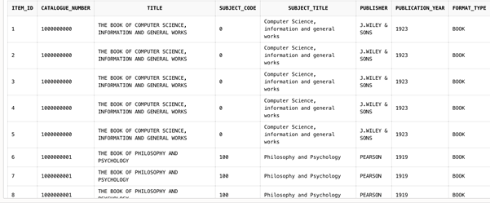

The script above returns each resource that is a ‘BOOK’ and returns a total of 50 items. The total of 50 items that are books is the entirety that the library contains of that type. There are 3 other format_type available, each equalling the same total of 50 items per format_type. The screenshots prove this, however, only the first 8 items which are books are shown here. The remaining 50 can be seen if you scroll down after inputting the Query script into Oracle SQL Live. This would be useful for library members attempting to find a book version of a particular title.

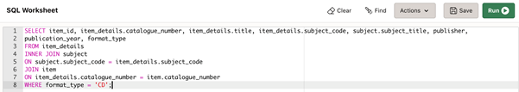Query of Each Subject Code for Each CD Item

SELECT item_id, item_details.catalogue_number, item_details.title, item_details.subject_code, subject.subject_title, publisher,

publication_year, format_type

FROM item_details

INNER JOIN subject

ON subject.subject_code = item_details.subject_code

JOIN item

ON item_details.catalogue_number = item.catalogue_number

WHERE format_type = 'CD';

The script above returns each resource that is a ‘CD’ and returns a total of 50 items. The total of 50 items that are CDs is the entirety that the library contains of that type. There are 2 other format_type available, each equalling the same total of 50 items per format_type. The screenshots prove this. Similarly to the previous script, members can easily find CD copies of an item through this query. The entire CD items can be viewed on Oracle – we had to save space as the screenshots took up a large bit of word document. This code works perfectly as displayed in the above screenshot.

Query for Each Subject Code of Each DVD Item

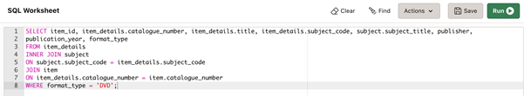

SELECT item_id, item_details.catalogue_number, item_details.title, item_details.subject_code, subject.subject_title, publisher,

publication_year, format_type

FROM item_details

INNER JOIN subject

ON subject.subject_code = item_details.subject_code

JOIN item

ON item_details.catalogue_number = item.catalogue_number

WHERE format_type = 'DVD';

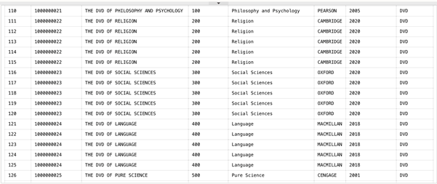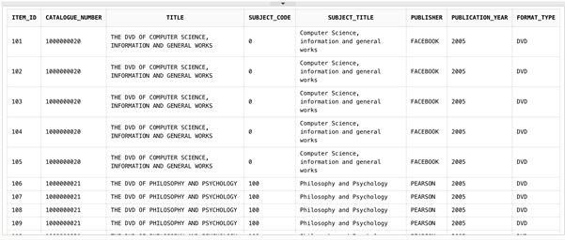

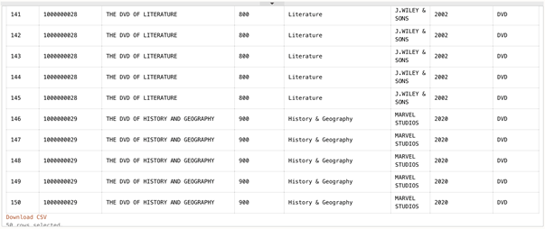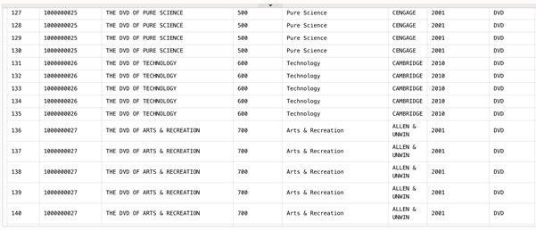The script above returns each resource that is a ‘DVD’ and returns a total of 50 items. The total of 50 items that are CDs is the entirety that the library contains of that type. There are 1 other format_type available and equalling the same total of 50 items per format_type. The screenshots prove this. Similarly to the previous script, members can easily find DVD copies of an item through this query.

Query for Each Subject Code for Each VHS Item

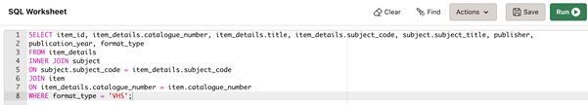

SELECT item_id, item_details.catalogue_number, item_details.title, item_details.subject_code, subject.subject_title, publisher,

publication_year, format_type

FROM item_details

INNER JOIN subject

ON subject.subject_code = item_details.subject_code

JOIN item

ON item_details.catalogue_number = item.catalogue_number

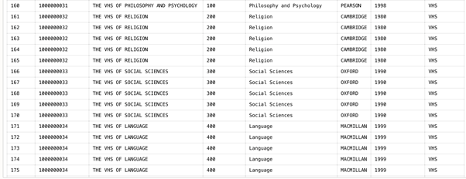WHERE format_type = 'VHS';

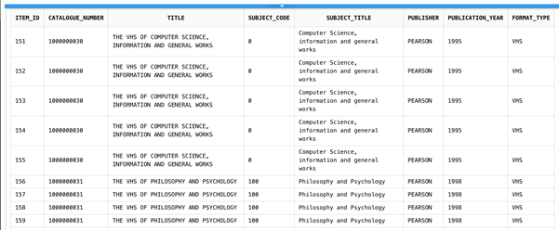

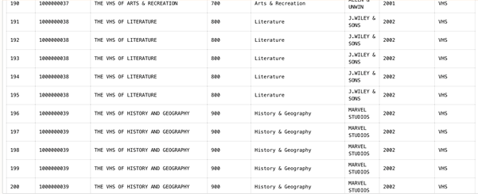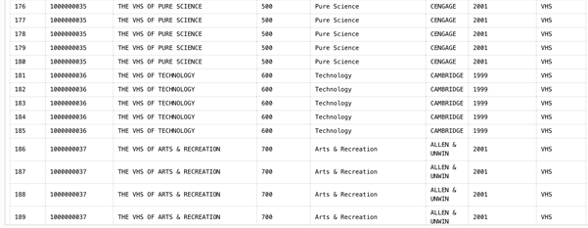

Query Script to Count How Many Copies of Each Type of Item are Held by the Library

Query to Count Total Number of Books in Library

SELECT COUNT(*) AS "Total Number of Books in Library" FROM (SELECT item_id, item_details.catalogue_number, item_details.title, item_details.subject_code, subject.subject_title, publisher,

publication_year, format_type

FROM item_details

INNER JOIN subject

ON subject.subject_code = item_details.subject_code

JOIN item

ON item_details.catalogue_number = item.catalogue_number

WHERE format_type = 'BOOK');

The above script is specifically used to count the total number of Book items that exist in the Library when inventory is full and none of the items have been on loan. This query would be useful for admins to do a total inventory count for stock check for a particular type of item, in this case for books.

Query to Count Total Number of CDs in Library

SELECT COUNT(*) AS "Total Number of CDs in Library" FROM (SELECT item_id, item_details.catalogue_number, item_details.title,

item_details.subject_code, subject.subject_title, publisher,

publication_year, format_type

FROM item_details

INNER JOIN subject

ON subject.subject_code = item_details.subject_code

JOIN item

ON item_details.catalogue_number = item.catalogue_number

WHERE format_type = 'CD');

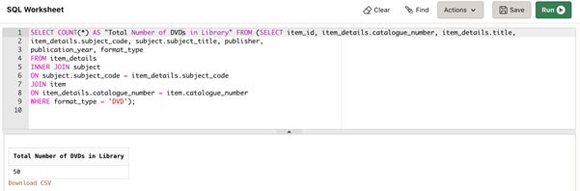

The above script is specifically used to count the total number of CD items that exist in the Library when inventory is full and none of the items have been on loan. This query would be useful for admins to do a total inventory count for stock check for a particular type of item, in this case for CDs.

Query to Count Total Number of DVDs in Library

SELECT COUNT(*) AS "Total Number of DVDs in Library" FROM (SELECT item_id, item_details.catalogue_number, item_details.title,

item_details.subject_code, subject.subject_title, publisher,

publication_year, format_type

FROM item_details

INNER JOIN subject

ON subject.subject_code = item_details.subject_code

JOIN item

ON item_details.catalogue_number = item.catalogue_number

WHERE format_type = 'DVD');

The above script is specifically used to count the total number of DVD items that exist in the Library when inventory is full and none of the items have been on loan. This query would be useful for admins and members to do a total inventory count for stock check for a particular type of item, in this case for DVDs.

Query to Count Total Number of VHSs in Library

SELECT COUNT(*) AS "Total Number of VHS in Library" FROM (SELECT item_id, item_details.catalogue_number, item_details.title,

item_details.subject_code, subject.subject_title, publisher,

publication_year, format_type

FROM item_details

INNER JOIN subject

ON subject.subject_code = item_details.subject_code

JOIN item

ON item_details.catalogue_number = item.catalogue_number

WHERE format_type = 'VHS');

The above script is specifically used to count the total number of DVD items that exist in the Library when inventory is full and none of the items have been on loan. This query would be useful for admins and members to do a total inventory count for stock check for a particular type of item, in this case for VHSs.

Location of Each Resource

SELECT item_id, item.catalogue_number, item.location_id, floor_number, shelf_mark,

subject_code, title, format_type

FROM item_location

INNER JOIN item

ON item.location_id = item_location.location_id

INNER JOIN item_details

ON item.catalogue_number = item_details.catalogue_number

ORDER BY item_id ASC;

The code above provides the direct location of each resource item in the library. This query would be useful for library members seeking out particular books and they could use a simple WHERE clause to identify a specific title or a different format of the same title name. The information provided by the various attributes within this query also shows all format types that exist for a particular item along with its location. The screenshots are too long to fit in a word document, but the script is a guarantee that you will find all the items and their resource location.

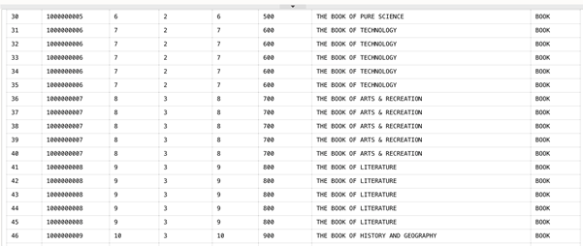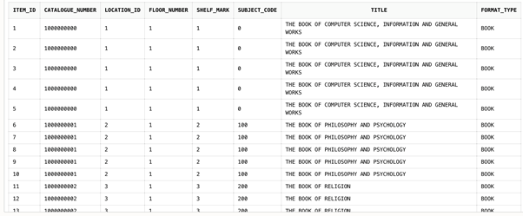

Query to Find Items with item_id values above 50

SELECT item_id, item.catalogue_number, item.location_id, floor_number, shelf_mark,subject_code, title, format_type

FROM item_location

INNER JOIN item

ON item.location_id = item_location.location_id

INNER JOIN item_details

ON item.catalogue_number = item_details.catalogue_number

WHERE item_id > 50

ORDER BY item_id ASC;

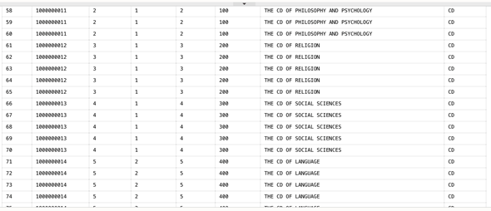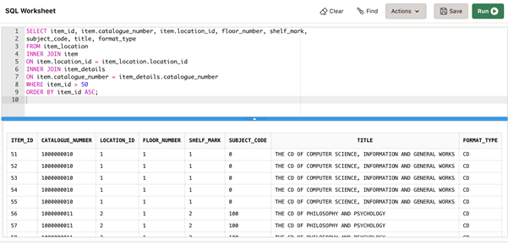Same explanation as the previous script, difference here is merely the WHERE clause to find item_id over 50 and ordered ascendingly.

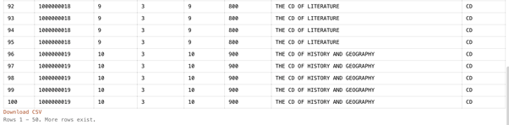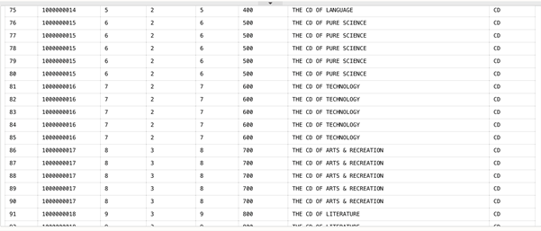

**Query to find item_id values above 100**

SELECT item_id, item.catalogue_number, item.location_id, floor_number, shelf_mark,

subject_code, title, format_type

FROM item_location

INNER JOIN item

ON item.location_id = item_location.location_id

INNER JOIN item_details

ON item.catalogue_number = item_details.catalogue_number

WHERE item_id > 100

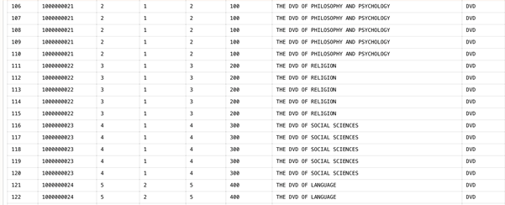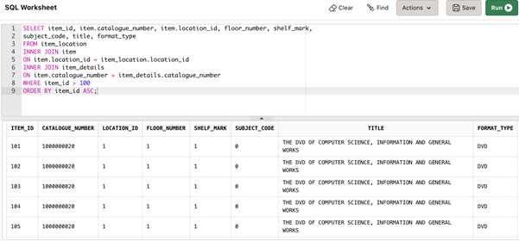ORDER BY item_id ASC;

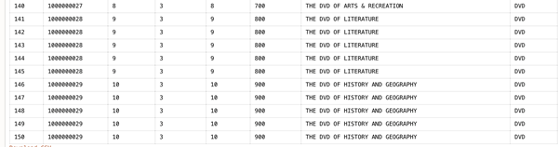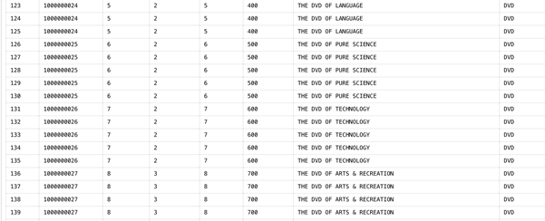

**Query to Find item_id values above 150**

SELECT item_id, item.catalogue_number, item.location_id, floor_number, shelf_mark,

subject_code, title, format_type

FROM item_location

INNER JOIN item

ON item.location_id = item_location.location_id

INNER JOIN item_details

ON item.catalogue_number = item_details.catalogue_number

WHERE item_id > 150

ORDER BY item_id ASC;

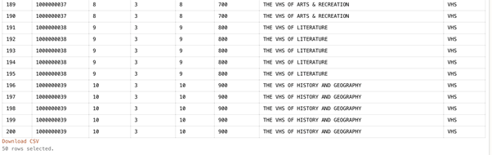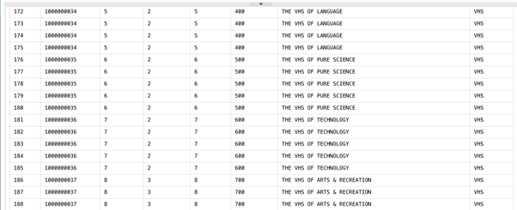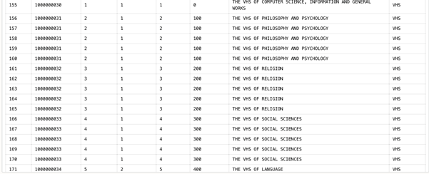

Query of Total Number of Members of the Library and Number of Students and Staff

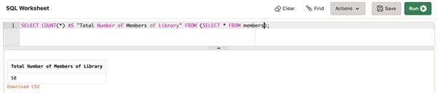SELECT COUNT(*) AS "Total Number of Student Member of Library" FROM (SELECT * FROM members);

SELECT COUNT(*) AS "Total Number of Student Member of Library" FROM (SELECT * FROM members

WHERE member_class = 'STUDENT');

SELECT COUNT(*) AS "Total Number of Student Member of Library" FROM (SELECT * FROM members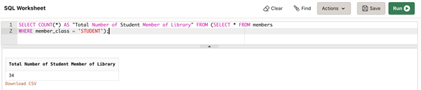

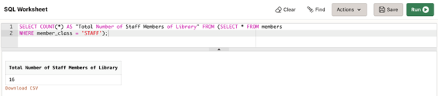WHERE member_class = 'STAFF');

The query scripts above are useful for library admins to identify the total number of members in the library. This saves time from writing out complex queries.

Query for Student and Staff member details

SELECT * FROM members;

There are over 50 members in the library – to save space in the document only the first 15 have been screenshotted. However, this query yields all 50 members of the library. This query is useful as it displays all members and their contact details. This would be useful for a library admin if they needed to contact a member.

Query to View All Loans Held by Members Including If Loans have been Returned or Overdue

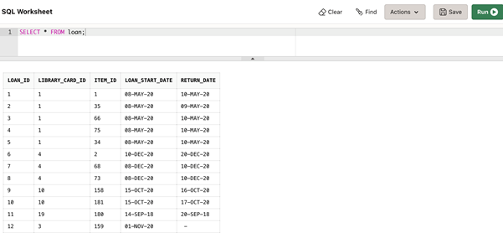SELECT * FROM loan;

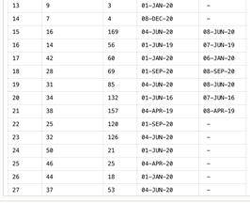

The query script above show all loans both returned and currently on loan and is effective in detailing all the contents of the table loan. Library admins will find this useful.

Query to view Current Loans Exclusively

SELECT * FROM current_loans

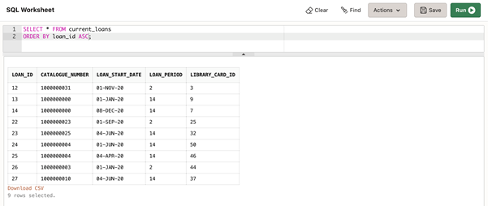ORDER BY loan_id ASC;

The script above lists all the current loans available in the library. This query essentially shows the contents of the VIEW table current_loans. Useful for admins to see what is on loan and useful for members to know who has which item and when they can expect it to be back in the library.

Record of Previous Loans

SELECT * FROM popular_item

This query is the contents of the VIEW popular_item.

Query to Identify Fine Payment Details of Members

SELECT * FROM fines_payment;

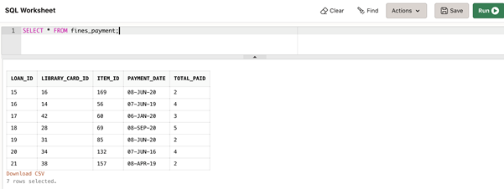

This query highlights all the fines that have been paid. This is good for general accounting and tracking members that have a history of withholding loans longer than their loan period allows.

Query to Find Current Suspended Members of the Library

SELECT * FROM current_suspensions;

This query is essentially displaying the contents of the VIEW current_suspensions and it is useful for identifying members of the library who have been suspended.

Security & Legal Considerations

The usage of parameterized queries would have allowed us to further constrain user input and lower the ability of hackers to utilize SQL injection attacks on our library system. Unfortunately, this feature does not work properly on Oracle SQL live so we were unable to implement any queries that used this technique.

As this is a UK based system, we must comply with the UK Data Protection Act 2018. One aspect is which is that personal data should be removed from the system once it is no longer necessary to keep it. In our system this would be when students graduate or when staff members leave the university.

Restricting data types where possible to only NUMBER or DATE ensures the appropriateness of data entered into the system, maintaining database integrity and utility. One of our views (current_suspensions) exposes sensitive user data such as email addresses. However, in practice if our database application were to be deployed it would be password protected and any functionality including the querying of views would be limited to a protected administrator account. Furthermore, arbitrary queries are disallowed, with administrators being limited to the 12 pre-defined queries we have created. This removes any possibility of malicious actors compromising the integrity of our database system.